**TEAM ID**

ASSIGNMENT - 4

# **:** PNT2022TMID34287

**PROJECT NAME :** SMART FASHION RECOMMENDER APPLICATION

## Question-1:

1. Pull an Image from docker hub and run it in docker playground.

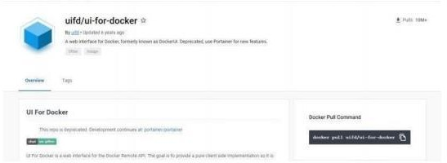

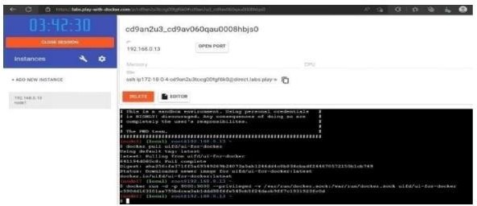

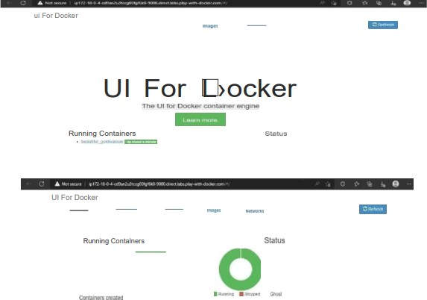

## Question-2:

1. 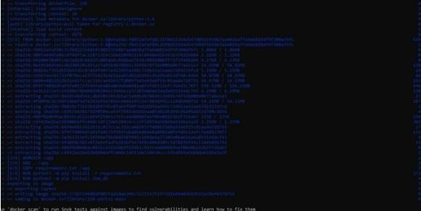Create a docker file for the jobportal application and deploy it in Docker desktop application.

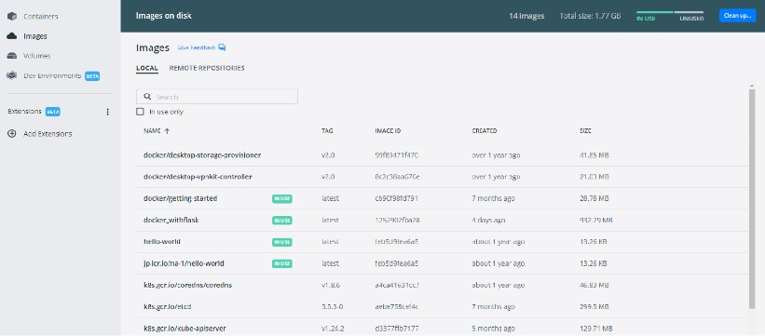

## Question-3:

1. Create a IBM container registry and deploy helloworld app or jobportalapp. Solution :

<html>

<body>

Hello, IBM Cloud

</body>

</html> applications:

buildpack: https://github.com/cloudfoundry/staticfile-buildpack.git host: simple-website-${random}

name: simple-website-${random} memory: 64M

stack: cflinuxfs2

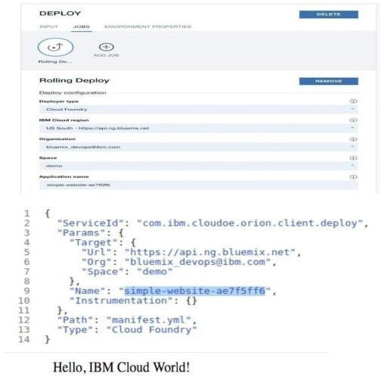

## Question-4:

1. 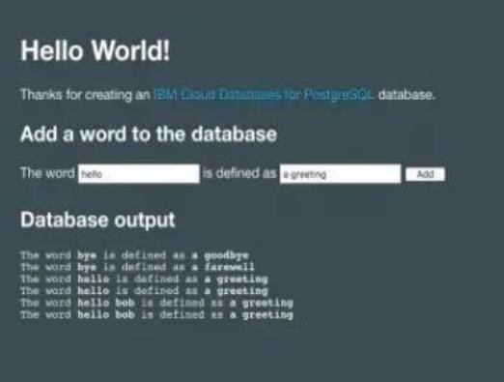Create a Kubernetes cluster in IBM cloud and deploy helloworld image or jobportal image and also expose the same app to run in nodeport.